<https://myapps.senecacollege.ca/login>

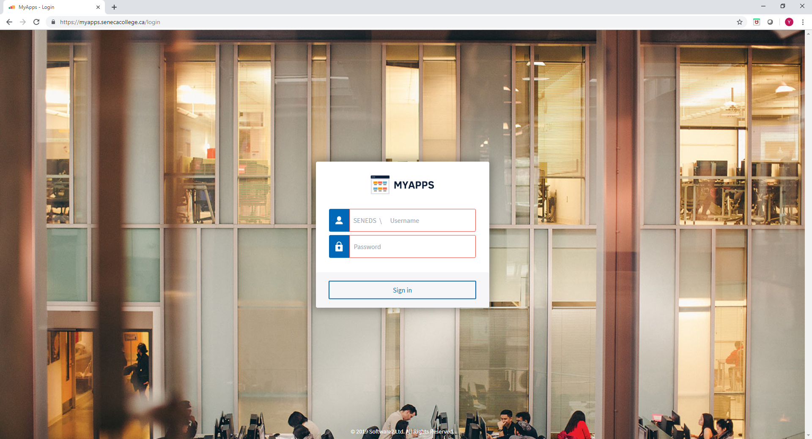

Login with your regular Seneca user id and password.

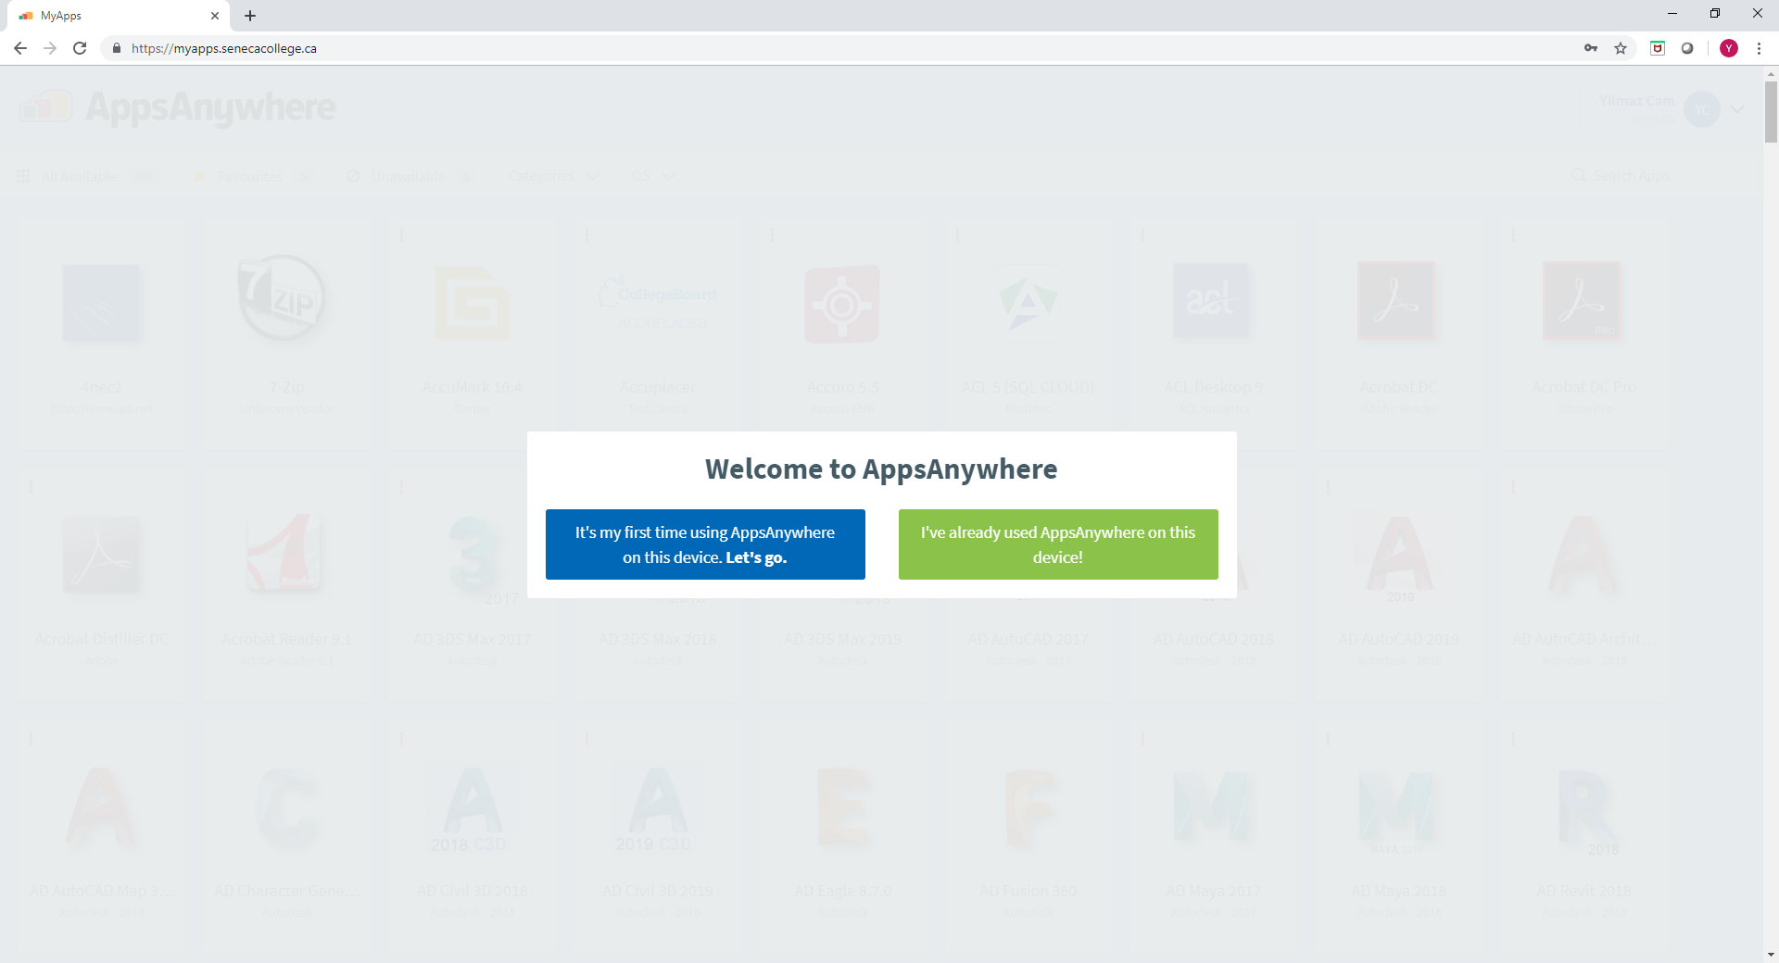

Install MyApps on your computer first.

Search Visual Studio

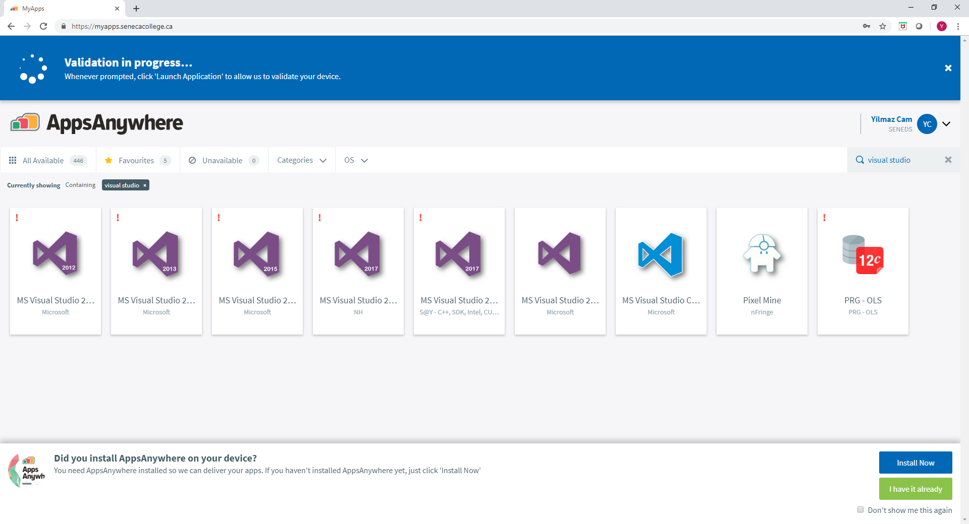

Select Visual Studio 2017 that has C++

